**Exercise**

**1.**

**2.**

**3.**

**4.**



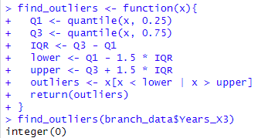**5.**